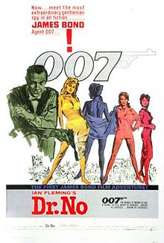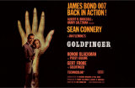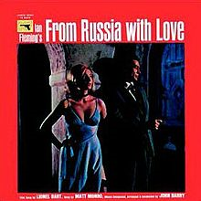

1

50 pts. Open the file, **bondreceipts.xlsx**. In class, we worked on the books of Ian Fleming. Except for your instructor, most people are more interested in the movies of Ian Fleming’s creation, James Bond and this file lists out the movies, each movie’s box office (which means what the movie grossed as far as ticket and movie right sales), the cost of producing the movie and an inflation factor. In the end, we want to determine the actor who was most popular with movie audiences.

A dollar in 1962 was worth more than a dollar to day. Economists would say that it could buy $7.17 today. That is what we mean by the inflation factor. For this problem, this is needed for fairness in our determination.

So, you are asked to create two new columns.

1. For the year that a movie was filmed and put in movie theaters, what was the net profit which is the box office minus(-) production costs. Call this field: **net profit**
2. Now, take the figure calculated above and multiply this by that year’s inflation factor to bring this to this year’s dollars. We will call this field: **adjusted net profit**

With what you have calculated above, let’s do a subtotal calculation. This is accomplished by an appropriate sort and subtotal as done in class.

1. Sort the excel spreadsheet so that the actors who have played James Bond are bunched together. Remember, with the books, we started the same way by bunching the titles together.
2. Run a subtotal that breaks on the actor giving the sum of the **adjusted net profit** (the second column you created above) for all the Bond movies he made.
3. Now, let’s sort on this subtotaled spreadsheet on the **adjusted net profit** column. In the end, we should see in reverse (descending) order, a list of actors sorted in decreasing order by the total net profit of all the James Bond movies they made.
4. Let’s finish this off with a bar (column) chart.

Save this file using your name and the fact that this is problem 1. For example, if it was me, it would be: Marc Rauer James Bond Problem 1. Look on the last page for instructions in sending this file to your instructor.

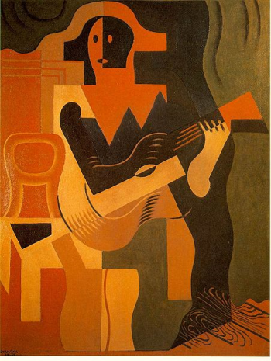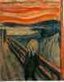

2

50pts. As you may be aware, part-time instruction at CCP is very lucrative and with this money your instructor has been able to acquire quite an art collection. Below I’ve listed my painting collection.

|  |  |  |
| --- | --- | --- |
| Artist | Name Of work | Appraised Value |
| Pablo Picasso | Menu Of Els Quatre Gats | 811000 |
| Rembrandt | The Music Party | 1733000 |
| Pablo Picasso | Bull race | 430000 |
| Anthony Van Dyke | Marchesa Balbi | 304000 |
| Johannes Vermeer | Woman Holding a Balance | 439000 |
| Juan Gris | Harlequin With Guitar | 1847000 |
| Rembrandt | The Raising of Lazarus | 1826000 |
| Munch | The Scream | 2475000 |

You can see the author, the work and the appraised value. I need to calculate the insurance costs for my collection. Perhaps, you could help. To start this, enter my collection into a new excel spreadsheet.

Insurance is not cheap and it’s made up of several parts which you’ll have to keep track of.

1. Every objet d’art (painting) has a $500 policy fee. This is applied before any other cost. You must pay this for each of your line items.
2. The coverage is rated at 7.5%. This means that a million dollar painting costs 75000 to insure. Use this 7.5% figure to create a column indicating this for each painting.
3. Any paintings above 1.5 million (1500000) has an additional insurance cost of $3000. Create and populate a new column for this.
4. Total insurance cost for each painting is the sum of parts 1, 2 and 3. Create this column.
5. Sort these pictures so that the highest insurance premiums (prices) appear first.

Now the next few questions apply to the entire set of paintings. The answers should be new rows created at the bottom of the paintings list

1. What is the total appraised value in my collection?
2. What is the average appraised value of each piece in my collection?
3. What is the total insurance cost for my collection?
4. What is the average insurance cost for each picture in my collection?

Save this file using your name and the fact that this is problem 1. For example, if it was me, it would be: Marc Rauer Art Works Problem 2. Look below for instructions in sending this file to your instructor.

Saturday, Dec 11: Submitting your files:

You should have 2 files per the 2 questions of the test. Save them first onto your machine or perhaps on a flash memory device. You have 3 ways of sending. The best would be to Email me these as an attachment making sure to CC yourself at an Email account that you deal with regularly.

Emails should be directed to [777rauer@voicenet.com](mailto:777rauer@voicenet.com). Your Email should have a subject similar to something like Marc Rauer Prob 1 if I was doing this test. Having your name prominently displayed is especially necessary if your Email address is obscure and your name not readily known.

The Carbon copy is for your protection. If I should fail to receive your Email, or I can’t open it, I will request you to send this Email again.

A second way is to give me your flash memory device but I need it until the tests are marked. If using flash memory, your file name should be similar to what was indicated for subject above in discussing Emails.

Finally, I will bring my own flash memory device(s).

Before sending, and before closing your Excel spreadsheet, make sure the save to your disk is not corrupted. In addition, please remember that once your machine is closed down, your files are gone if you saved any files on your machine.