Adventure!

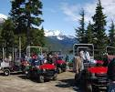

* Self Guided Tours Available
* All Vehicles and gear provided
* Open March through October

To book your adventure, call [555-8928](http://www.marshcreeklake.com/boat-rental/)

Explore Scenic Trails with *breathtaking* views as you travel through meadows, forests, streams and mountains in an off-road vehicle