Dated: | December 29th, 1965
To: | Gildrose Ltd
From: | Royal Accountants and Auditors
Re: | The Fleming Book Publication Numbers, revision
Note: | A prior letter from this office did not include the question of returns – books not sold sent to the distributor. This Letter supercedes the previous letter

Per your request, our auditors have analyzed the number of books sold in the calendar year 1964 written by the late Ian Fleming. Your company holds the distribution and publishing rights to Mr Fleming’s works.

Below is a table indicating the books and their sales in several areas. Europe, Asia and the Americas have been broken down into several regions. We have also included Gildrose’s profit for each book. Returns have also been calculated for each distribution point. Per your agreement with the publisher each return costs your company 50 cents ($.50). However, the agreement precludes negative after returns profit.

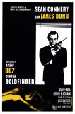
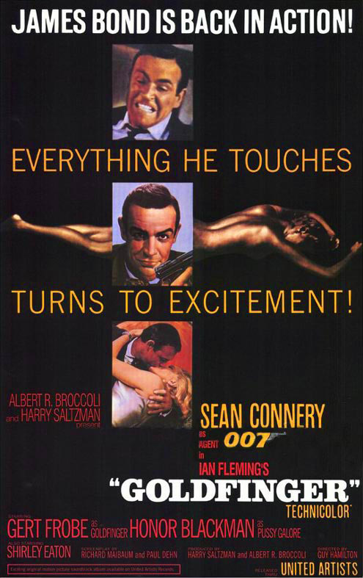
You should understand that 1964 is probably a high water mark in the sales of these books. The publicity surrounding Mr Fleming at the time of his death 8/12/64, and the subsequent publicity about the release of the Movie, Goldfinger, based on Mr Fleming’s 1959 book of the same name, may have spurred sales of all his books. We have included some of the movie advertising here to show the interest in Mr Fleming’s works as they have been revised for the screen.

Below is a table indicating sales of all of Mr Fleming’s works in print.

title | Continent | Distribution Locale | Books Distributed | Returns | Gildrose's Royalty/book
Casino Royale | North America | Eastern US | 43105 | 1052 | 0.83
Live and Let Die | North America | Eastern US | 38920 | 899 | 0.35
Moonraker | North America | Eastern US | 45133 | 1790 | 0.39
Diamonds are Forever | North America | Eastern US | 15062 | 488 | 0.52
From Russia With Love | North America | Eastern US | 80099 | 545 | 0.83
Dr No | North America | Eastern US | 91378 | 1803 | 0.72
Goldfinger | North America | Eastern US | 52958 | 1366 | 0.68
Thunderball | North America | Eastern US | 24599 | 506 | 0.69
For Your Eyes Only | North America | Eastern US | 12816 | 369 | 0.58
The Spy Who Loved Me | North America | Eastern US | 87850 | 915 | 0.23
On Her Majesty's Secret Service | North America | Eastern US | 99140 | 2677 | 0.5
You Only Live Twice | North America | Eastern US | 21600 | 37 | 0.72
The Man With The Golden Gun | North America | Eastern US | 134220 | 5823 | 0.39
The Diamond Smugglers | North America | Eastern US | 18041 | 884 | 0.24
Thrilling Cities | North America | Eastern US | 6884 | 104 | 0.47
Chitty Chitty Bang Bang | North America | Eastern US | 1441 | 30 | 0.18
Casino Royale | North America | Western US & Mexico | 13359 | 394 | 0.76
Live and Let Die | North America | Western US & Mexico | 46171 | 914 | 0.39
Moonraker | North America | Western US & Mexico | 32556 | 864 | 0.74
Diamonds are Forever | North America | Western US & Mexico | 11518 | 319 | 0.35
From Russia With Love | North America | Western US & Mexico | 67294 | 161 | 0.56
Dr No | North America | Western US & Mexico | 80739 | 920 | 0.35
Goldfinger | North America | Western US & Mexico | 94222 | 2930 | 0.35
Thunderball | North America | Western US & Mexico | 2502 | 98 | 0.21
For Your Eyes Only | North America | Western US & Mexico | 81038 | 1392 | 0.55
The Spy Who Loved Me | North America | Western US & Mexico | 91279 | 610 | 0.27
On Her Majesty's Secret Service | North America | Western US & Mexico | 73787 | 1306 | 0.61
You Only Live Twice | North America | Western US & Mexico | 53589 | 1785 | 0.26
The Man With The Golden Gun | North America | Western US & Mexico | 26556 | 458 | 0.41
The Diamond Smugglers | North America | Western US & Mexico | 16660 | 498 | 0.28
Thrilling Cities | North America | Western US & Mexico | 14663 | 454 | 0.15
Chitty Chitty Bang Bang | North America | Western US & Mexico | 7994 | 73 | 0.32
Casino Royale | Europe | England | 10743 | 29 | 0.25
Live and Let Die | Europe | England | 24305 | 584 | 0.26
Moonraker | Europe | England | 46951 | 621 | 0.46
Diamonds are Forever | Europe | England | 19400 | 810 | 0.99
From Russia With Love | Europe | England | 6202 | 198 | 0.37
Dr No | Europe | England | 99346 | 3822 | 0.88
Goldfinger | Europe | England | 27459 | 544 | 0.34
Thunderball | Europe | England | 60778 | 1566 | 0.7
For Your Eyes Only | Europe | England | 48247 | 1411 | 0.7
The Spy Who Loved Me | Europe | England | 35834 | 592 | 0.5
On Her Majesty's Secret Service | Europe | England | 59313 | 728 | 0.68
You Only Live Twice | Europe | England | 126430 | 2127 | 0.93
The Man With The Golden Gun | Europe | England | 87677 | 1562 | 0.44
The Diamond Smugglers | Europe | England | 13687 | 269 | 0.5
Thrilling Cities | Europe | England | 1611 | 56 | 0.29
Chitty Chitty Bang Bang | Europe | England | 15967 | 262 | 0.26
Casino Royale | Europe | Western Europe | 14940 | 71 | 0.9
Live and Let Die | Europe | Western Europe | 46080 | 679 | 0.86
Moonraker | Europe | Western Europe | 25316 | 697 | 0.75
Diamonds are Forever | Europe | Western Europe | 29362 | 1322 | 0.74
From Russia With Love | Europe | Western Europe | 96368 | 3471 | 0.25
Dr No | Europe | Western Europe | 4375 | 132 | 0.81
Goldfinger | Europe | Western Europe | 11982 | 379 | 0.71
Thunderball | Europe | Western Europe | 82638 | 1617 | 0.59
For Your Eyes Only | Europe | Western Europe | 77106 | 968 | 0.28
The Spy Who Loved Me | Europe | Western Europe | 40531 | 606 | 0.39
On Her Majesty's Secret Service | Europe | Western Europe | 50292 | 1733 | 0.29
You Only Live Twice | Europe | Western Europe | 104089 | 2713 | 0.79
The Man With The Golden Gun | Europe | Western Europe | 17316 | 439 | 0.73
The Diamond Smugglers | Europe | Western Europe | 14032 | 572 | 0.26
Thrilling Cities | Europe | Western Europe | 16099 | 505 | 0.19
Chitty Chitty Bang Bang | Europe | Western Europe | 15026 | 222 | 0.54
Casino Royale | Japan | Asia | 8810 | 202 | 0.62
Live and Let Die | Japan | Asia | 9734 | 238 | 0.32
Moonraker | Japan | Asia | 14728 | 505 | 0.56
Diamonds are Forever | Japan | Asia | 1481 | 47 | 0.35
From Russia With Love | Japan | Asia | 20159 | 252 | 0.33
Dr No | Japan | Asia | 23653 | 1090 | 0.37
Goldfinger | Japan | Asia | 53691 | 187 | 0.55
Thunderball | Japan | Asia | 37779 | 614 | 0.65
For Your Eyes Only | Japan | Asia | 45608 | 1314 | 0.69
The Spy Who Loved Me | Japan | Asia | 66726 | 2037 | 0.49
On Her Majesty's Secret Service | Japan | Asia | 51740 | 1363 | 0.48
You Only Live Twice | Japan | Asia | 15096 | 359 | 0.36
The Man With The Golden Gun | Japan | Asia | 144483 | 2724 | 0.39
The Diamond Smugglers | Japan | Asia | 4393 | 51 | 0.41
Thrilling Cities | Japan | Asia | 6958 | 221 | 0.16
Chitty Chitty Bang Bang | Japan | Asia | 6926 | 193 | 0.19
Casino Royale | South East Asia | Asia | 18700 | 598 | 0.64
Live and Let Die | South East Asia | Asia | 509 | 5 | 0.5
Moonraker | South East Asia | Asia | 26014 | 561 | 0.67
Diamonds are Forever | South East Asia | Asia | 49859 | 1093 | 0.36
From Russia With Love | South East Asia | Asia | 11198 | 121 | 0.54
Dr No | South East Asia | Asia | 90437 | 2317 | 0.25
Goldfinger | South East Asia | Asia | 75457 | 1089 | 0.17
Thunderball | South East Asia | Asia | 22671 | 492 | 0.46
For Your Eyes Only | South East Asia | Asia | 12330 | 518 | 0.36
The Spy Who Loved Me | South East Asia | Asia | 97983 | 2089 | 0.4
On Her Majesty's Secret Service | South East Asia | Asia | 24944 | 112 | 0.48
You Only Live Twice | South East Asia | Asia | 147602 | 3052 | 0.7
The Man With The Golden Gun | South East Asia | Asia | 167712 | 3685 | 0.21
The Diamond Smugglers | South East Asia | Asia | 16256 | 260 | 0.19
Thrilling Cities | South East Asia | Asia | 1049 | 29 | 0.28
Chitty Chitty Bang Bang | South East Asia | Asia | 15287 | 261 | 0.07
Casino Royale | South America | South America | 14319 | 293 | 0.75
Live and Let Die | South America | South America | 22131 | 698 | 0.36
Moonraker | South America | South America | 48611 | 505 | 0.36
Diamonds are Forever | South America | South America | 8750 | 41 | 0.38
From Russia With Love | South America | South America | 96751 | 3795 | 0.44
Dr No | South America | South America | 19567 | 549 | 0.46
Goldfinger | South America | South America | 36737 | 1075 | 0.72
Thunderball | South America | South America | 33134 | 768 | 0.25
For Your Eyes Only | South America | South America | 88963 | 2192 | 0.32
The Spy Who Loved Me | South America | South America | 41784 | 780 | 0.3
On Her Majesty's Secret Service | South America | South America | 6610 | 144 | 0.2
You Only Live Twice | South America | South America | 148474 | 6629 | 0.78
The Man With The Golden Gun | South America | South America | 19499 | 112 | 0.56
The Diamond Smugglers | South America | South America | 6968 | 156 | 0.13
Thrilling Cities | South America | South America | 670 | 130 | 0.12
Chitty Chitty Bang Bang | South America | South America | 14013 | 209 | 0.12

